**Life in a smart city**

**‘Smart cities’ is a term used to describe the use of smart technologies and data as the means to solve cities’ sustainability challenges. Many cities are in the process of making themselves smart, using data and technology to improve transport, energy use, health and air quality or to drive economic growth. Others are being built to be smart from the start. So this is a term that relates to the present and to the future.**

# What is a smart city?

**Cities are centres of innovation and creativity, but they also face great challenges such as rapid urbanisation, climate change and increased pressure on city services like transport and healthcare. To address the challenges and capitalise on the opportunities, cities are encouraged to become ‘smart cities’. However the term ‘smart city’ is broad and ambiguous, with no agreed definition or consensus on how cities should approach the agenda.**

A number of smart city definitions exist; some have a broad focus while others focus on technology and data or citizens.

For example, the British Standards Institute (BSI) defines smart cities as ‘the effective integration of physical, digital and human systems in the built environment to deliver sustainable, prosperous and inclusive future for its citizens’ (BSI, 2014).

Cisco defines the term as those cities that adopt ‘scalable solutions that take advantage of information and communications technology (ICT) to increase efficiencies, reduce costs, and enhance quality of life’ (Falconer and Mitchell, 2012).

What most smart city definitions have in common is that they consider the use of smart technologies and data as the means to solve cities’ sustainability challenges – economic, social and environmental issues. Smart technologies can be classified, broadly, as ICT solutions. They range from expensive hardware solutions such as city control centres, smart grids and autonomous vehicles, through to much lower cost solutions such as smartphone apps, online platforms that crowdsource citizens’ ideas and low-cost environmental sensors. Data is also central to smart cities, in particular the use of big data and open data.

The approaches to smart city initiatives can be classified into two main approaches: ‘top-down’ and ‘bottom-up’ (Centre for Cities, 2014). Top-down approaches focus on technology, efficiency and master planning, integrating data from different systems into a central operations centre. Bottom-up approaches focus on citizens and how they can use innovative technologies, such as social media, mobile applications and open data to create solutions to issues that matter to them and enable behaviour change.

So do smart cities already exist or are they a future aspiration? Smart cities are created, they don’t simply exist or emerge, but there is no end point. Rather, becoming a smart city is a process by which cities use smart technologies and innovative approaches to address the challenges they face, helping them to become more resilient and liveable.

# World urbanisation

**Today, more than half of the world’s population, 3.5 billion people, live in urban areas, and by 2030 this will rise to 60%. Over the next decades there will be significant changes in the size and distribution of the world’s population.**

According to the United Nations (UN) close to half of the urban population live in cities of less than 500,000 people, but one in eight of us live in 28 mega cities – cities that have more than 10 million inhabitants, such as Tokyo, Delhi, Shanghai, Sao Paulo and London. The fastest growing cities have 500,000 to 1 million inhabitants and are located in Asia and Africa (UN, 2014).

Rapid urbanisation and unplanned growth pose significant challenges – greater demand for natural resources such as water and energy, increased pollution and impacts on biodiversity. The world’s cities occupy just 2% of the Earth’s land, but account for up to 80% of energy consumption and 75% of carbon dioxide emissions (UN, 2014).

Cities are major contributors to climate change but they’re also heavily vulnerable to it: they’re affected by rising sea levels, more frequent and stronger storms and cyclones, and more frequent extremes in heat and cold. These then impact on urban infrastructure and quality of life.

In many cities there’s also a shortage of housing, pressure on healthcare systems, and issues with poverty and crime.

Cities in the developing world face the toughest challenges, and it is here that 95% of future urban growth is predicted to take place by 2050. These cities will experience great change but have the lowest levels of resources and institutional capabilities to deal with that change. Already, 828 million people live in slums and the number keeps rising (UN, 2015).

[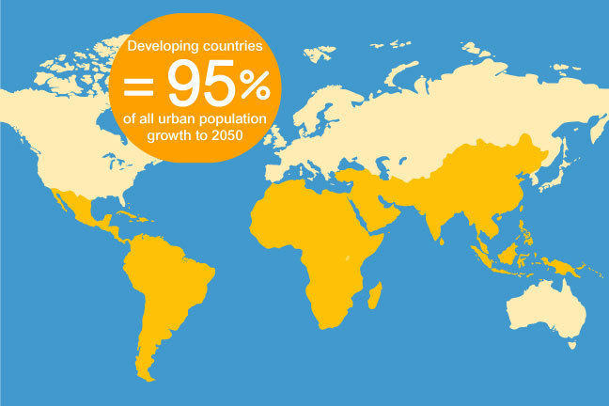](https://ugc.futurelearn.com/uploads/images/5e/e0/5ee0177a-69d4-4079-ba3e-407b6aad2ce6.jpg)Percentage of urban population growth predicted to be in developing countries (UN, 2014)

However, the concentration of people in cities can bring benefits: If managed well, population density allows increased access to jobs and cultural activities as well as to services such as healthcare, education and mobility, which could lead to longer life expectancy and poverty reduction.

Cities are dynamic places. They rely on the flow of people, ideas, resources and global connections. To thrive, cities need to meet the economic and social aspirations of the people who live there. They also need to manage their impacts on the environment in order to ensure that their growth is sustainable and that benefits are accessible to all.

Example of smart solution

Milton Keynes water management.

When there are water shortages, hosepipe bands are introduced. But how can we advise people to use water more efficiently to prevent such shortages?

One way to do this would be to provide an app on a smartphone or a tablet which provides you with a customised calendar which tells you whether your garden needs watering now or in the next few days. The app is integrating data from weather forecasts, satellite observations, ground sensors, and air temperatures to provide you with very specific advice about when to water the garden.

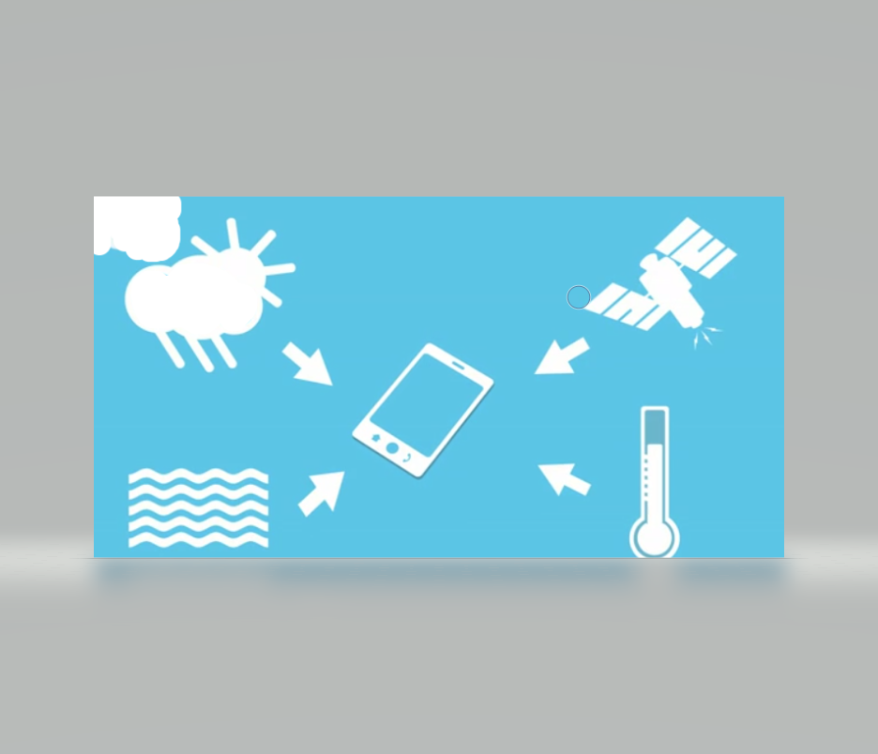

# Rio de Janeiro

**Rio de Janeiro is Brazil’s second largest city, with a population of over 6 million people. Rio is a lively, flamboyant city but, like many large cities, it faces problems such as crime, transport and ageing infrastructure. Being located just above sea level, the city is vulnerable to floods and landslides – natural disasters that are expected to increase with climate change. The city’s slum areas (favelas) are mostly built along the sides of the mountains so are particularly prone to natural disasters (UNICEF, 2012). Heavy rains have caused hundreds of casualties and destroyed homes.**

To address these issues, and in preparation for hosting both the 2014 FIFA World Cup and the 2016 Olympic Games, Rio’s mayor, Eduardo Paes, commissioned a City Operations Centre. It was designed by IBM and opened in 2010. The centre co-ordinates the activities of more than 300 municipal and state departments, plus private utility and transportation companies, integrating them into a single digital command-and-control system (Hamm, 2012).

Cameras send information back to the control centre’s hundreds of screens that show what is happening across the city in real time, and data analytics software is used to predict where traffic will flow, where accidents may happen and when flooding might hit. The centre uses a weather and flood forecasting program that predicts emergencies up to two days ahead of time. So the city can now position police, fire and rescue teams close to where problems are likely to occur, close off streets and use sirens to alert people to the danger, and residents can also sign up to receive messages to their mobile phones. Citizens can access the cameras to see what’s happening across the city.

However, this is not the only smart technology Rio is using. In stark contrast to the expensive City Operations Centre, in the favelas teenagers have been using kites and mobile technology to map the favelas’ social and environmental risks and to improve the lives of children and families in their communities (UNICEF, 2012). They fly kites with mobile phones attached and take photos of risks such as piles of rubbish, dangerous spots on paths and hazardous electricity cables. The photos are then tagged on a digital map, and the issues are sorted by type and urgency of response required (UNICEF, 2015). The UNICEF project is supported by the Municipality of Rio, the Municipal Secretariat of Health and Civil Defense, and a local organisation, CEDAPS (Centro de Promoção da Saúde).

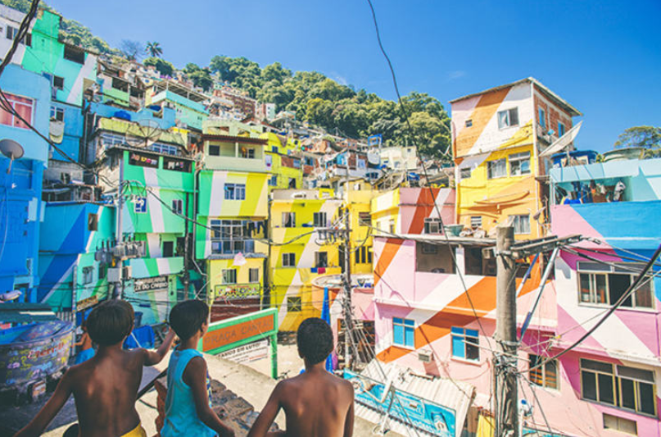

# What makes cities smart?

**Cities face complex challenges but they also offer a setting where people and organisations together can find solutions and opportunities. In smart cities, creativity, innovation and enterprise combine with technology and data to develop innovative solutions to urban challenges and citizens’ needs.**

As you have already seen, there are two broad approaches to smart cities – top-down and bottom-up. Top-down projects tend to be large scale and require significant investment, the City Operations Centre in Rio de Janeiro. Bottom-up solutions, on the other hand, such as the kite-flying project in Rio and the water app in Milton Keynes, tend to be lower cost and citizen-centred solutions. The term ‘smart city’ is also used interchangeably with other terms such as ‘future city’, ‘sustainable city’ and ‘digital city’, which can be equally broad and ambiguous. Smart city is currently the ‘most popular formulation for the future city, and is becoming a globally recognised term, replacing or co-existing with terms in other languages’ (Government Office for Science, 2014). It has displaced ‘sustainable city’ and ‘digital city’ as the word of choice to denote ICT-led urban innovation that addresses sustainability issues.

But becoming a smart city doesn’t necessarily mean being a resilient or sustainable city. Some smart city initiatives are driven by a vision of technology for the sake of technology. They fill their cities with smart technologies but they are not clear what problem these will solve and have little understanding of the needs of the citizens. These projects are often shaped by large technology companies who want to sell their smart city solutions. Amid the heavy marketing of smart city products and services it is hard to find evidence of impacts in the real world.

Others cities have set out with a belief that smart technology such as smart meters, electric vehicles, a smart grid or city control centre will solve their city challenges but concern themselves with working out where to deploy the smart technology rather than first being clear about its purpose, identifying the problem and then considering whether smart technology is the right solution.

An integrated approach to planning and management is needed if smart cities are to become more sustainable and resilient. The [100 Resilient Cities](http://www.100resilientcities.org/) network is helping cities around the world become more resilient to the physical, social and economic challenges that are a growing part of the 21st century. The network describes city resilience through four dimensions:

* **Health and wellbeing** – everyone living and working in the city has access to what they need to survive and thrive
* **Economy and society** – the social and financial systems that enable urban populations to live peacefully and act collectively
* **Leadership and strategy** – the processes that promote effective leadership, inclusive decision making, empowered stakeholders and integrated planning
* **Infrastructure and environment** – the man-made and natural systems that provide critical services, and that protect and connect urban assets, enabling the flow of goods, services and knowledge.

If smart cities want to solve city challenges, their best first step is to bring together city stakeholders (government, business, universities, community organisations, public services and citizens) to explore the complexity of the issues they face, and involve them in collaborative decision making and future planning of their city. This will be the start of a journey in which the city understands its issues and explores solutions which might include smart technology solutions.

# A city as a system of systems

**Solving city challenges is extremely difficult. A change in one city system can have unintended consequences in another system. For example, a city might reduce the number of its healthcare centres in a move to save money and concentrate resources. This might increase the number of car journeys people make as they travel to more distant healthcare centres. In turn this will lead to more traffic congestion and air pollution, which will impact health.**

Cities are very complex. They involve many systems, including energy, water and sewerage, food, transport, health and biodiversity, as well as economic, social and cultural systems. This network of systems, interconnections and flows can be described as a system of systems.

City government departments frequently work in silos when they’re trying to solve city problems; so, for example, transport is dealt with by transport planners and energy is dealt with by energy managers. The same is true of other organisations – water use is dealt with by the water supply company and energy use by many different energy suppliers. In reality the problems these sectors face are interconnected and an integrated approach has clear benefits.

‘Systems thinking’ is a discipline that provides skills and tools designed to address situations of complexity and uncertainty – situations that are difficult to grasp and to manage, and to which there are no simple answers.

How does systems thinking work? A system can be defined as a set of components that are interconnected for a purpose – a purpose that is identified as being of interest.

Here’s an example: let’s say a transport planning team wants to redesign a transport system in a city, and that the transport system has developed over the past 100 years. The traditional model of transport infrastructure would have transport as its focus. In a smart city, however, the team’s focus will be on goals such as mobility and connectivity for citizens.

One very powerful method of exploring systems is the drawing of systems diagrams. These facilitate learning about a system and enable expressions of connectivity and complexity. You can draw a systems diagram on your own, but they also work well when they’re created by a group.

# A rich picture

**One type of systems diagram is a rich picture. The idea of using pictures to explore issues is common to several problem-solving or creative thinking methods because we often communicate more easily in impressions and symbols than in words (The Open University, 2000). Pictures can both evoke and record insight into a situation.**

Rich pictures are a useful tool for exploring the challenges your city faces, which is the first step to identifying a problem you want to solve in your smart city project.

# A rich picture on your city's challenges

**Rich pictures are not intended as art. Drawing skills are strictly optional – stick figures and the like are just fine. The aim in creating one is to explore the main features of a situation in a free-form way. You draw the elements without trying to impose order or express relationships between them. They offer a way of observing complex situations without pre-judging challenges and possible solutions.**

Have a go now at drawing a rich picture of the challenges your city (or a city you know well) faces over the next 10 years.

# Wicked problems

Urban challenges such as poverty, sustainability, equality and quality of life are sometimes referred to as ‘wicked problems’, a term that was coined by the design theorist Horst Rittel. A wicked problem is a social or cultural problem that, for a number of different reasons, is difficult or impossible to solve. It’s a problem that the various stakeholders involved struggle to define, let alone solve (Rittel and Webber, 1973).

Think, for example, about what could be the solution to the problem of poverty. This problem is closely linked with many other issues – education, nutrition, the economy and so on. In solving a wicked problem, the solution to one aspect of the problem often reveals another problem, one that is possibly more complex. Often there will be no perfect solution to a wicked problem, although many solutions might fit well and help to mitigate the problem.

In dealing with the challenges that cities face, it is often changes to the structure and organisation of society that are needed, rather than quick ‘technology fixes’. Changing behaviour – the way we live, work and play – will be critical for cities if they are to become smart. However, technology can play an important role in facilitating behaviour change, for example in helping to reduce energy demand or change travel patterns.

Cities are well placed to operate as laboratories where, with the active participation of their citizens, they can explore problems and develop smart technologies, services and business models. Design thinking is a creative process that can help cities design meaningful solutions to wicked problems with their citizens (Stanford Design Program and the Standard Arts Institute, 2012).

As you’ve seen, there’s no agreed definition of what a smart city is, but it’s broadly accepted that a smart city uses smart technologies and data as the means to solve its sustainability challenges.

You’ve also heard that cities often make the mistake of starting with the technology rather than with the problem and why that problem is important to citizens. To develop your project you’ll need to choose a problem you wish to solve. You’ve already started to explore this using your rich picture. Before you choose your problem, however, you’ll learn how to work with citizens to design a smart cities project.

In developing a smart city project or programme it’s important to consider five core elements:

1. citizens
2. infrastructure, technology and data
3. enterprise and innovation
4. leadership and strategy
5. measurement and learning.

you’ll explore some other key issues:

1. the use of open data, which is an enabler of many smart city projects
2. sustainability, for which smart cities can be both an enabler and a threat
3. privacy and ethics, which is an increasing concern for citizens.

# Core elements of a smart city

**What are the five core elements of developing a smart city project or programme?**

How should you involve citizens? What’s different about the use of infrastructure, technology and data in a smart city, and who evolves and leads strategy? How is a city’s smartness measured and how can smart cities learn from each other?

